**Notes_Course1Week2**

**Lecture: The only free lunch in finance**

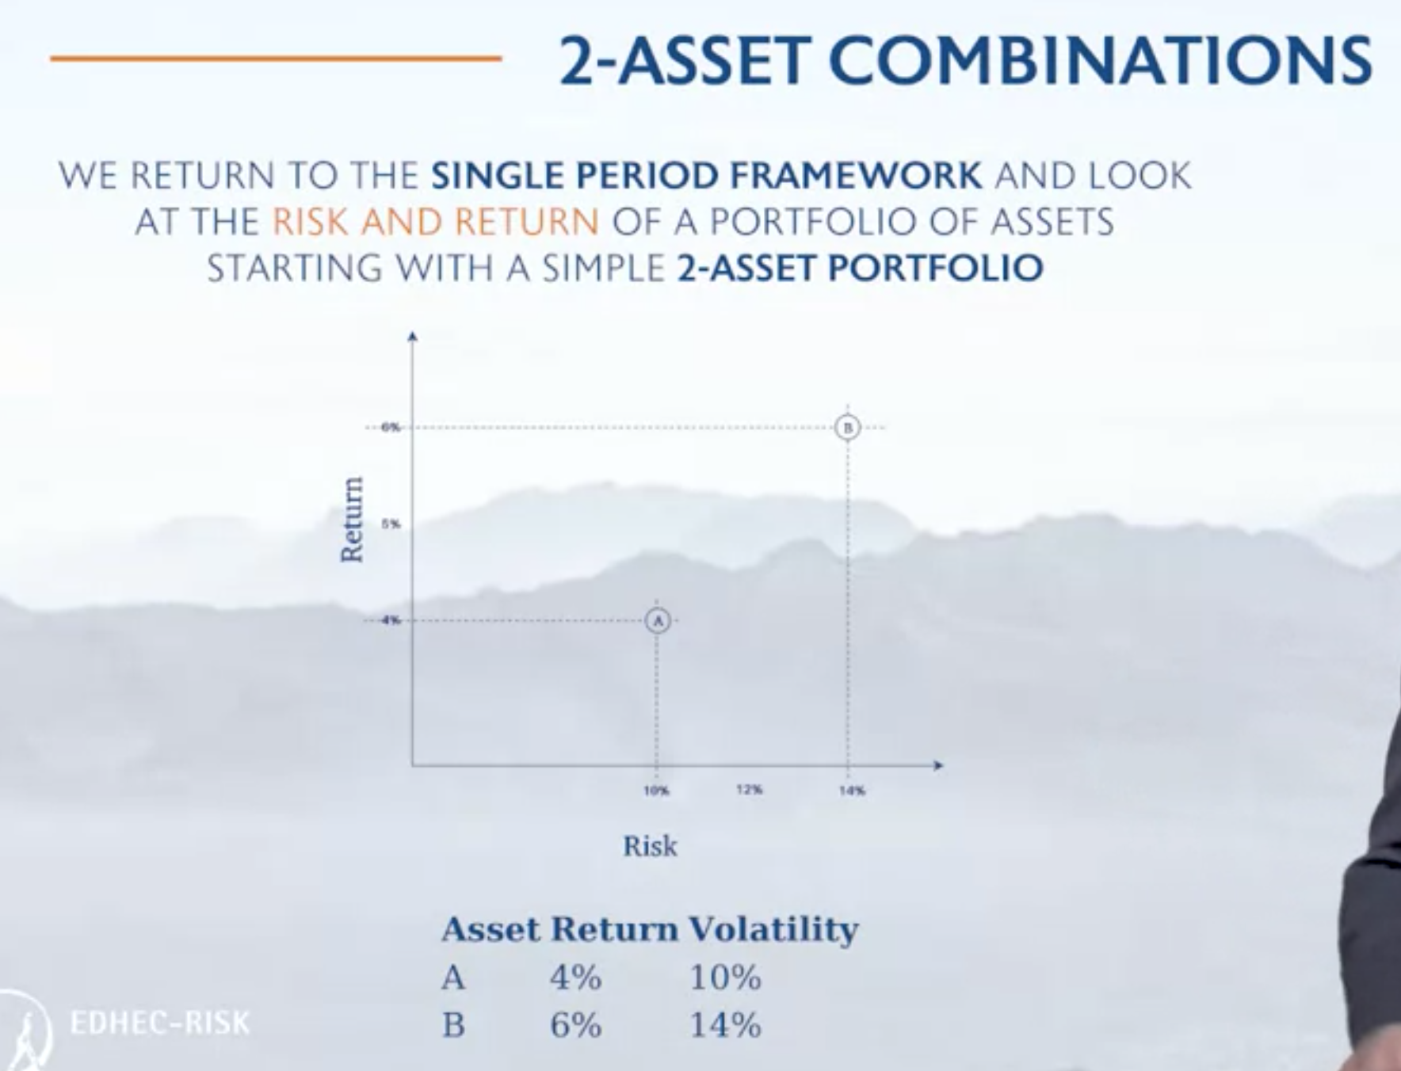

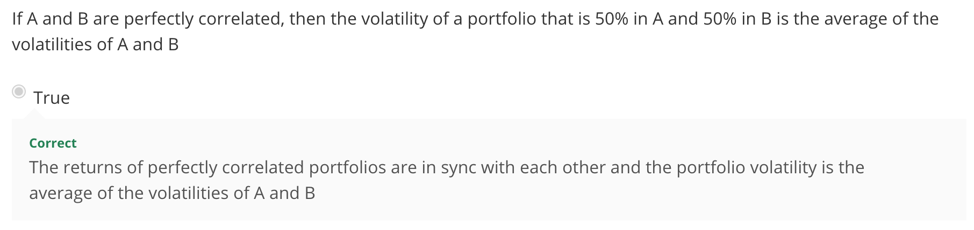

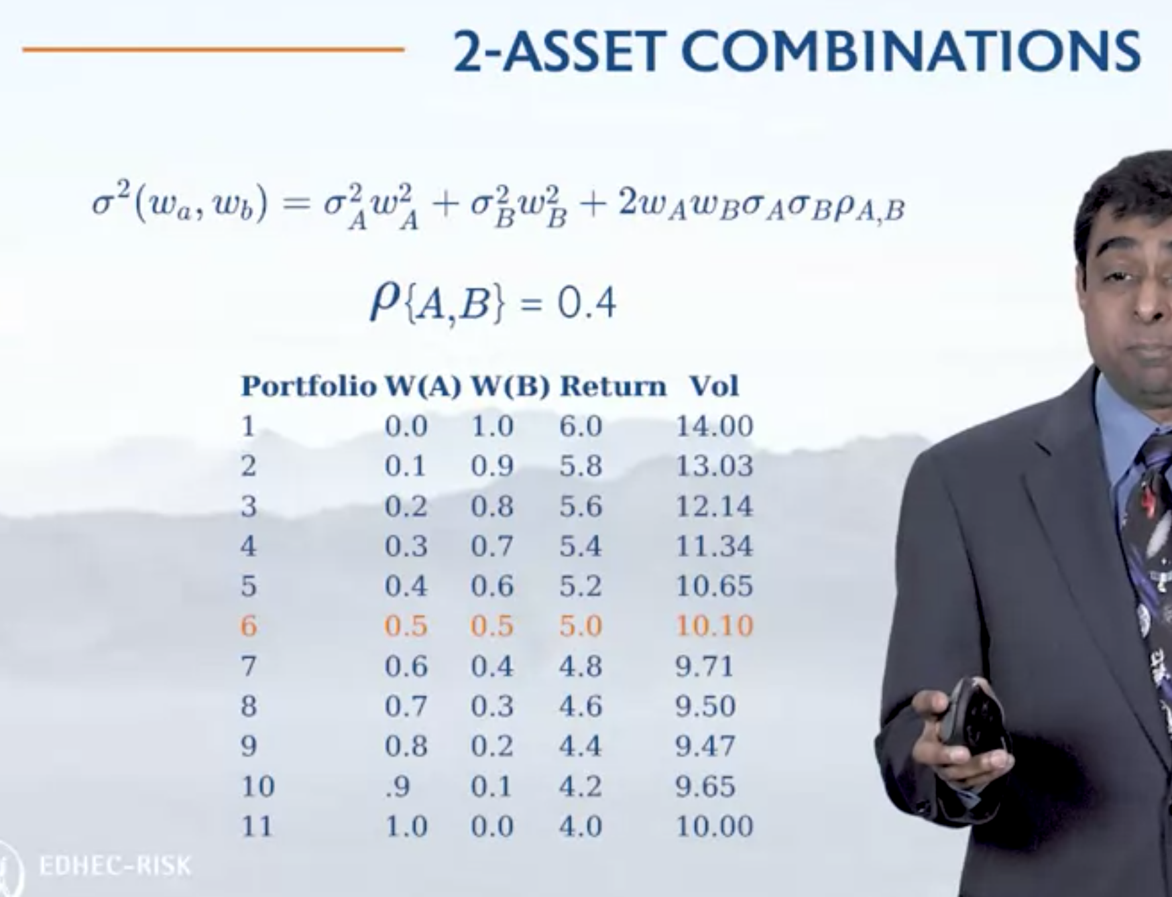

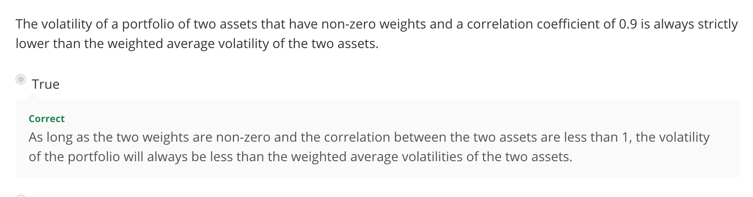

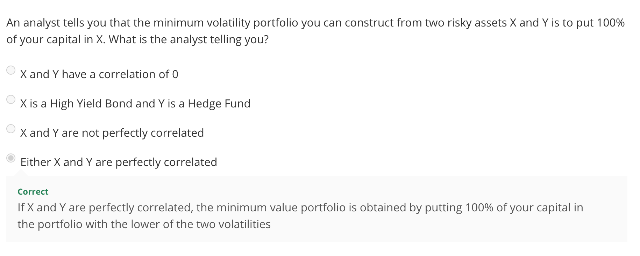

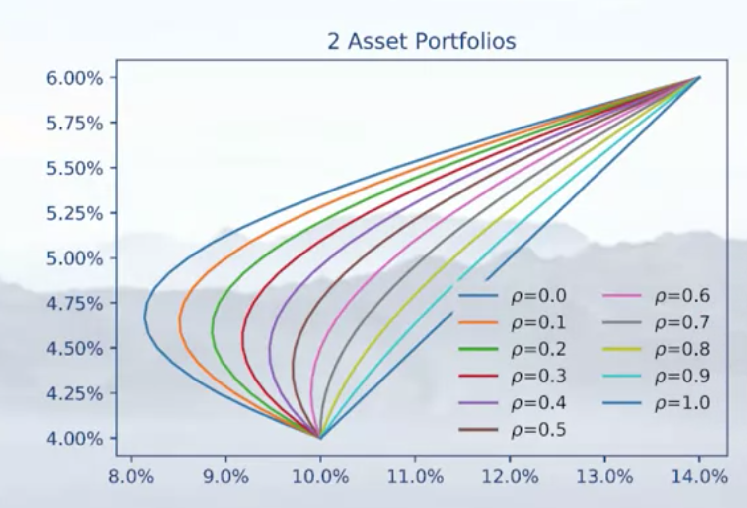

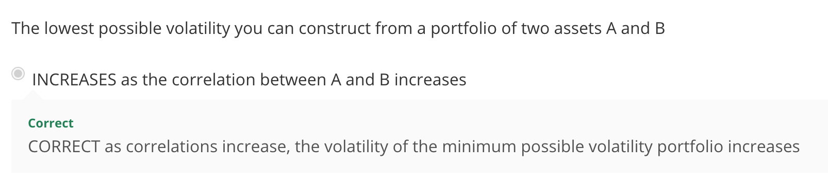

#### Might be worth reviewing Lab Session-Efficient frontier-Part 1

#### Lecture: Markowitz Optimization and the Efficient Frontier

Adding a third asset:

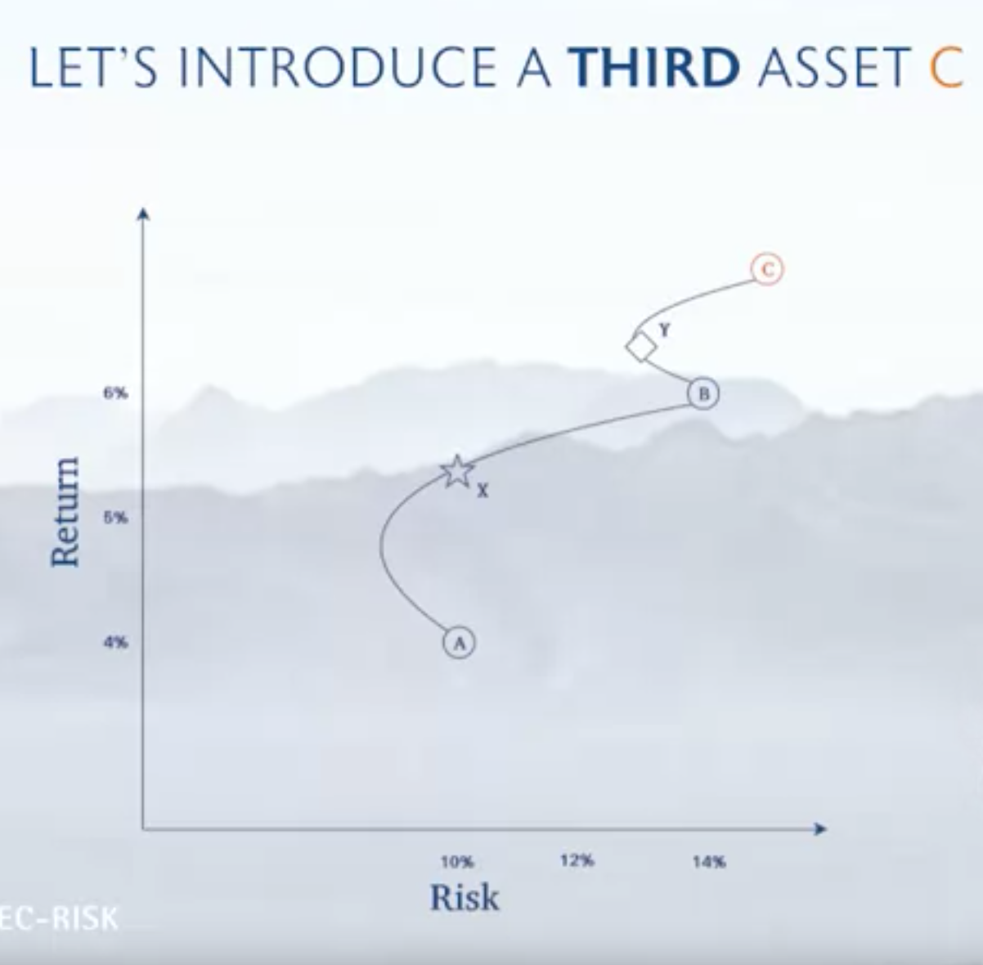

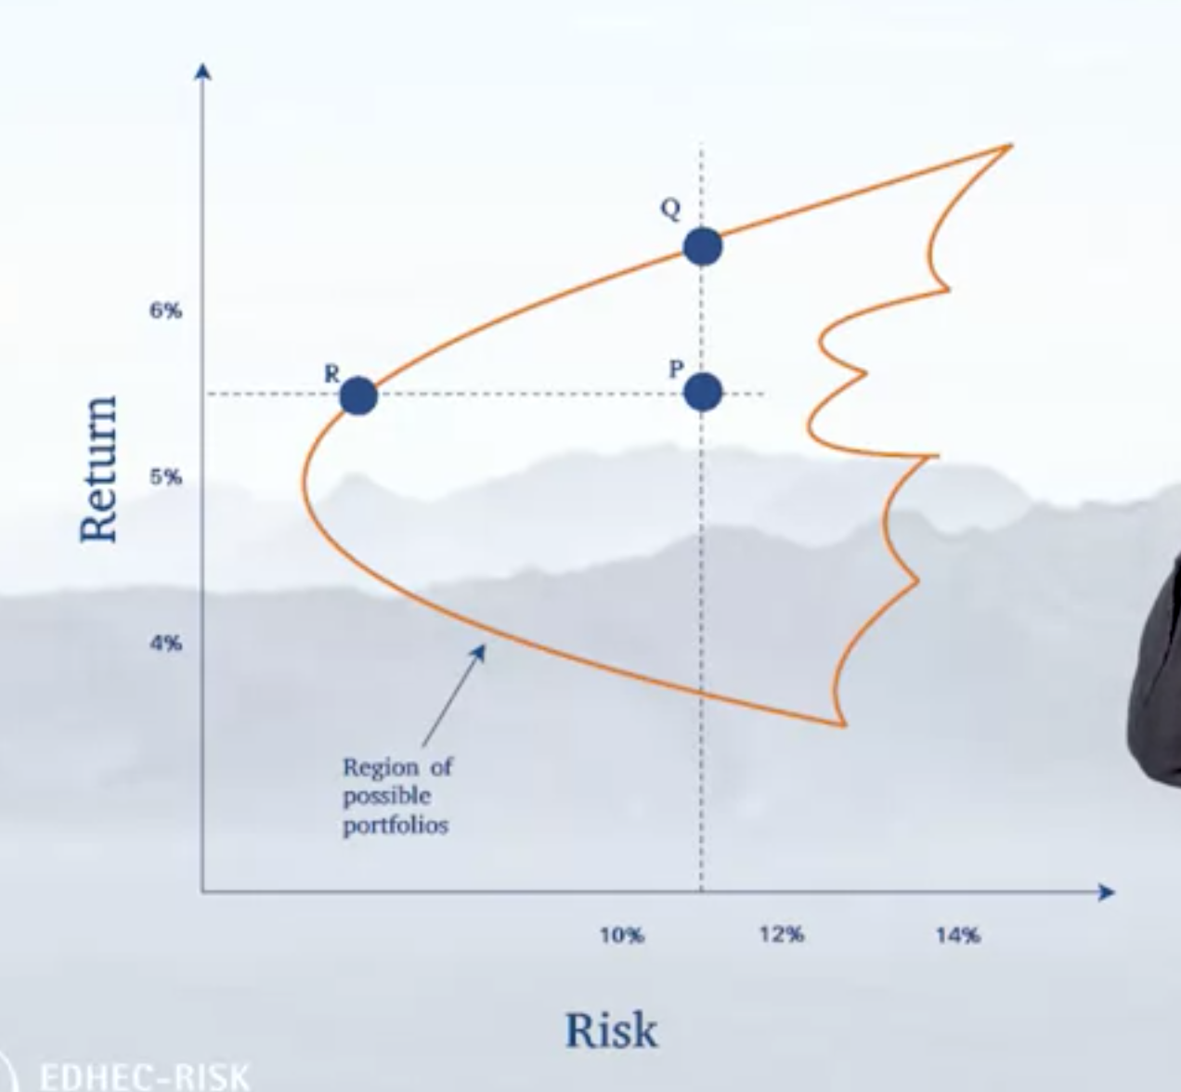

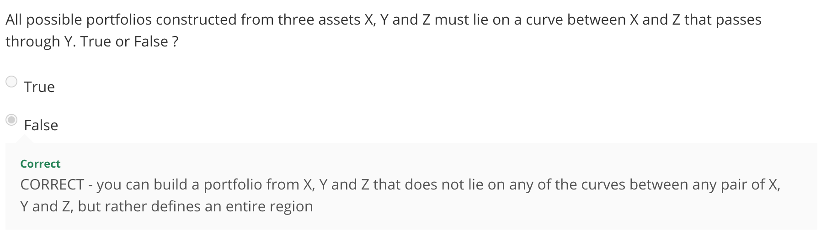

Dominant Portfolios (Dominating Portfolios) are just objectively better than others (ie, same risk, better return OR same return, lower risk)

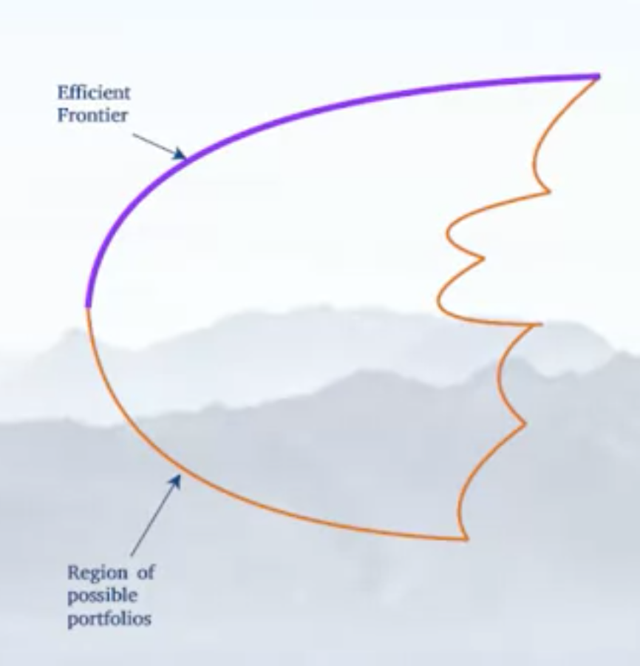

You never want to hold anything inside the region of the portfolios, you want to take things on the outter regions.

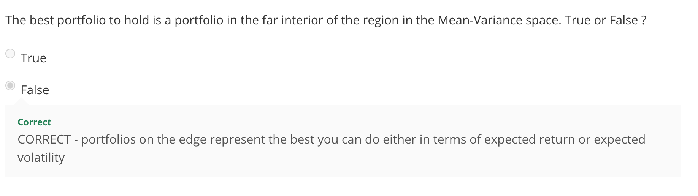

Mean-variance investor is someone who looks at returns vs volatility. Efficient frontier is absolutely the way to go

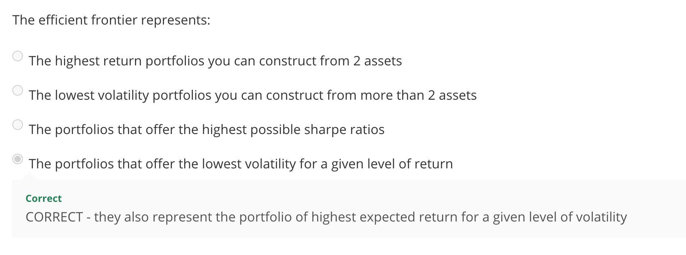

We only really care about one portfolio on the efficient frontier

**Applying quadprog to draw the efficient Frontier**

Convex optimization to draw the efficient frontier:

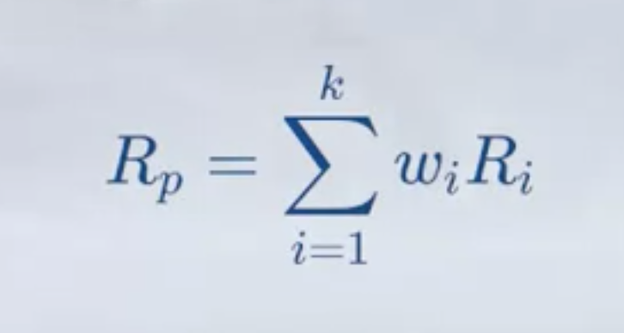

* The portoflio’s return is the weighted average returns of the constituents



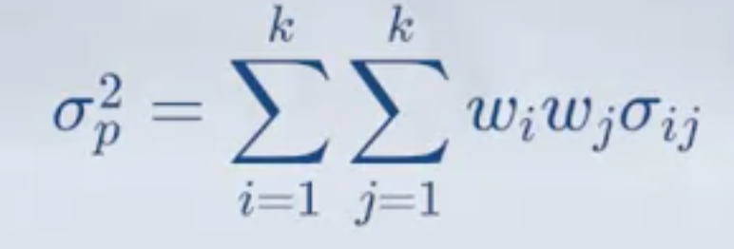

sigmaij is just the covariance

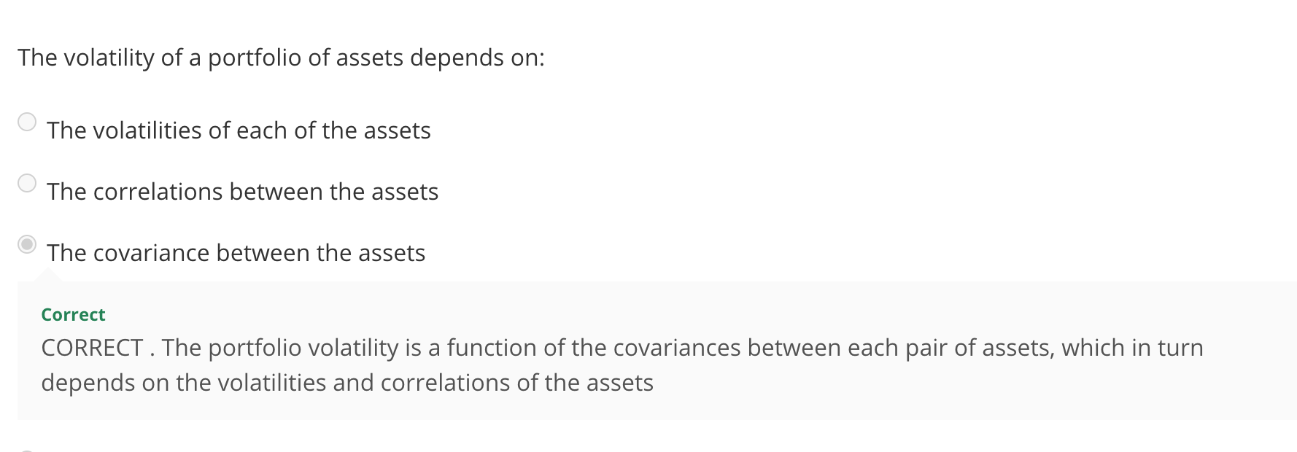

MATRIX NOTATION



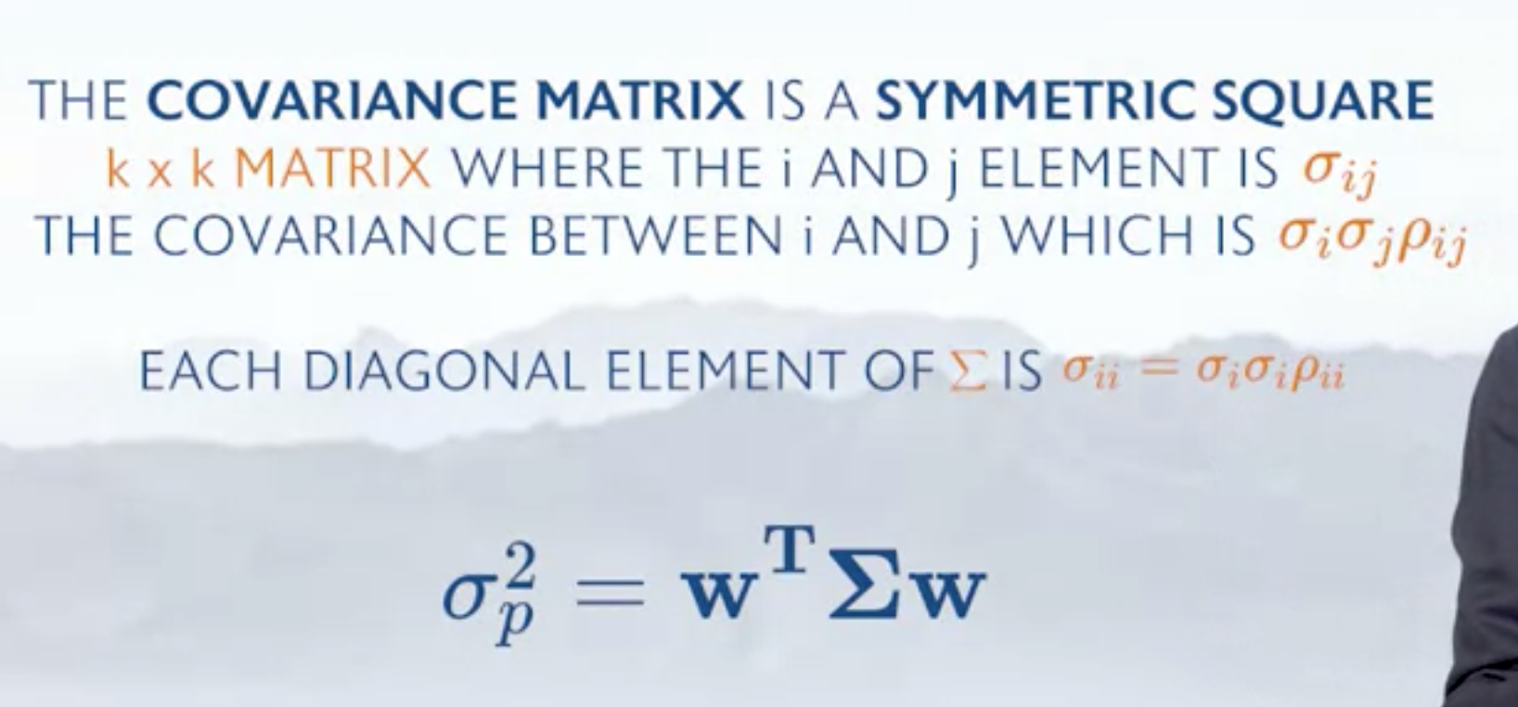

CONSTRUCTION:

1. Split the portfolio into the max and min returns
2. Spit it into horizontal grid lines
3. Plot the set of weights that minimizes volatility for that level of return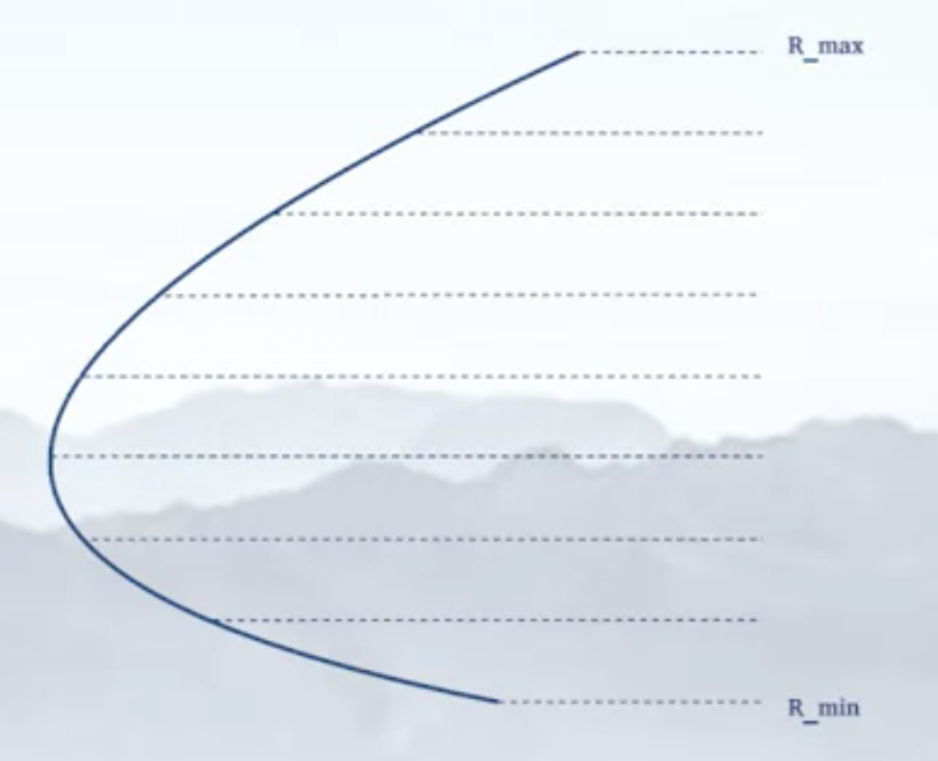
4. 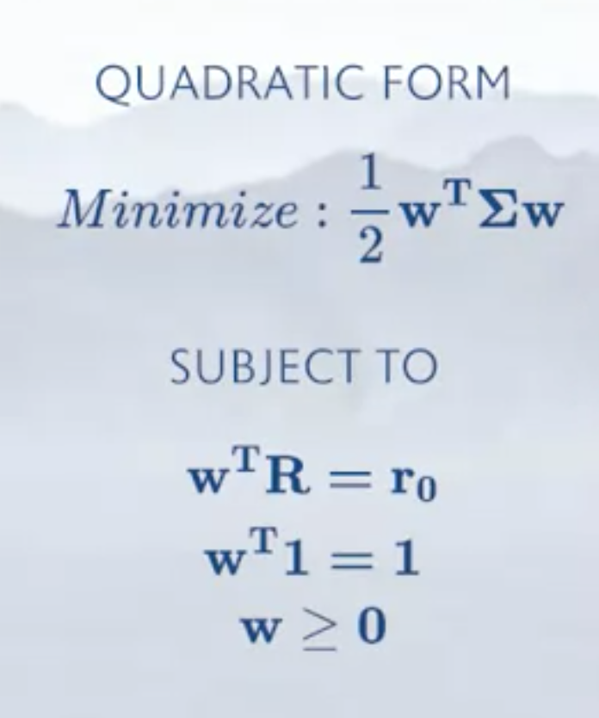

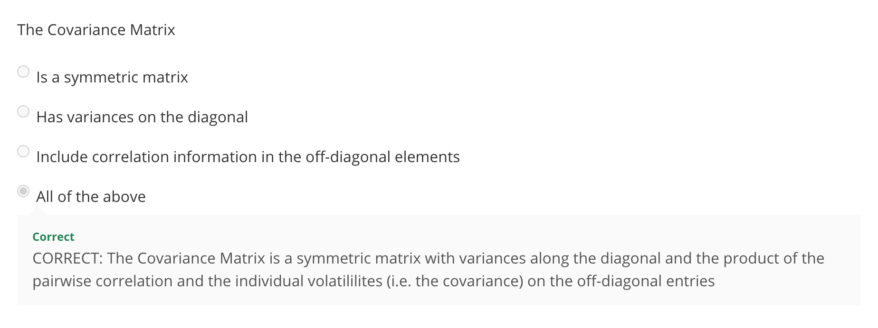

#### Lab Session-Asset Efficient Frontier-Part 2

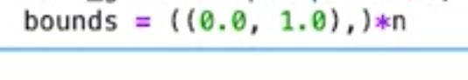 tuple of tuple, use that extra comma

* Target Return argument is essentially the array of “grid-lines”
  + You know what the return should be, now minimize the volatility to the best of your ability

**Fund Separation Theorem and the Capital Market Line**

* Efficient frontier drastically changes when a risk-free asset is added to the portfolio

Tangency portfolio

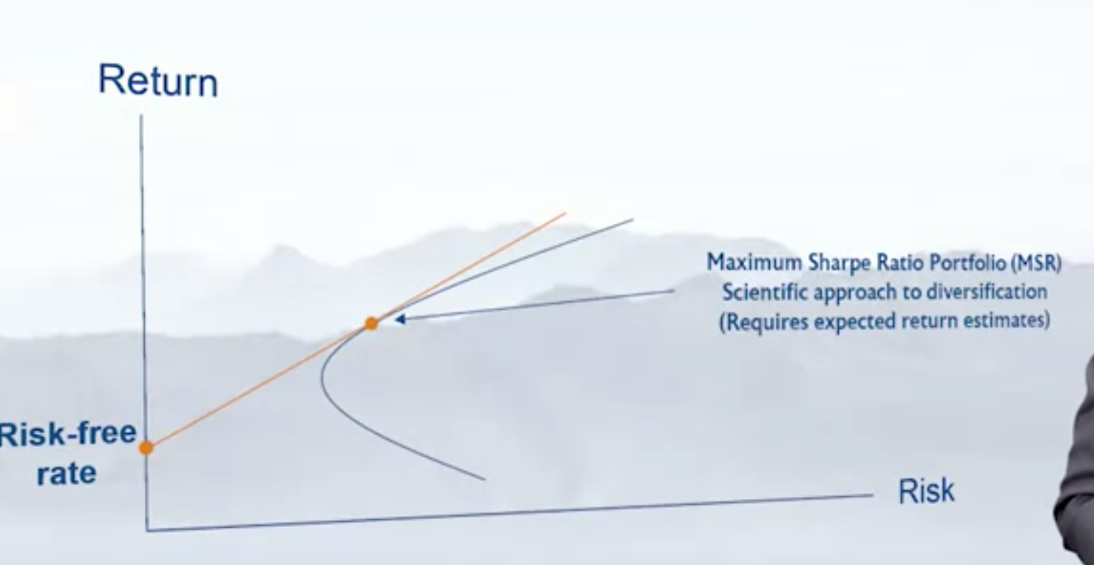

MAX SHARPE RATIO PORTFOLIO contains NO EXPOSURE TO UNREWARDED RISKS

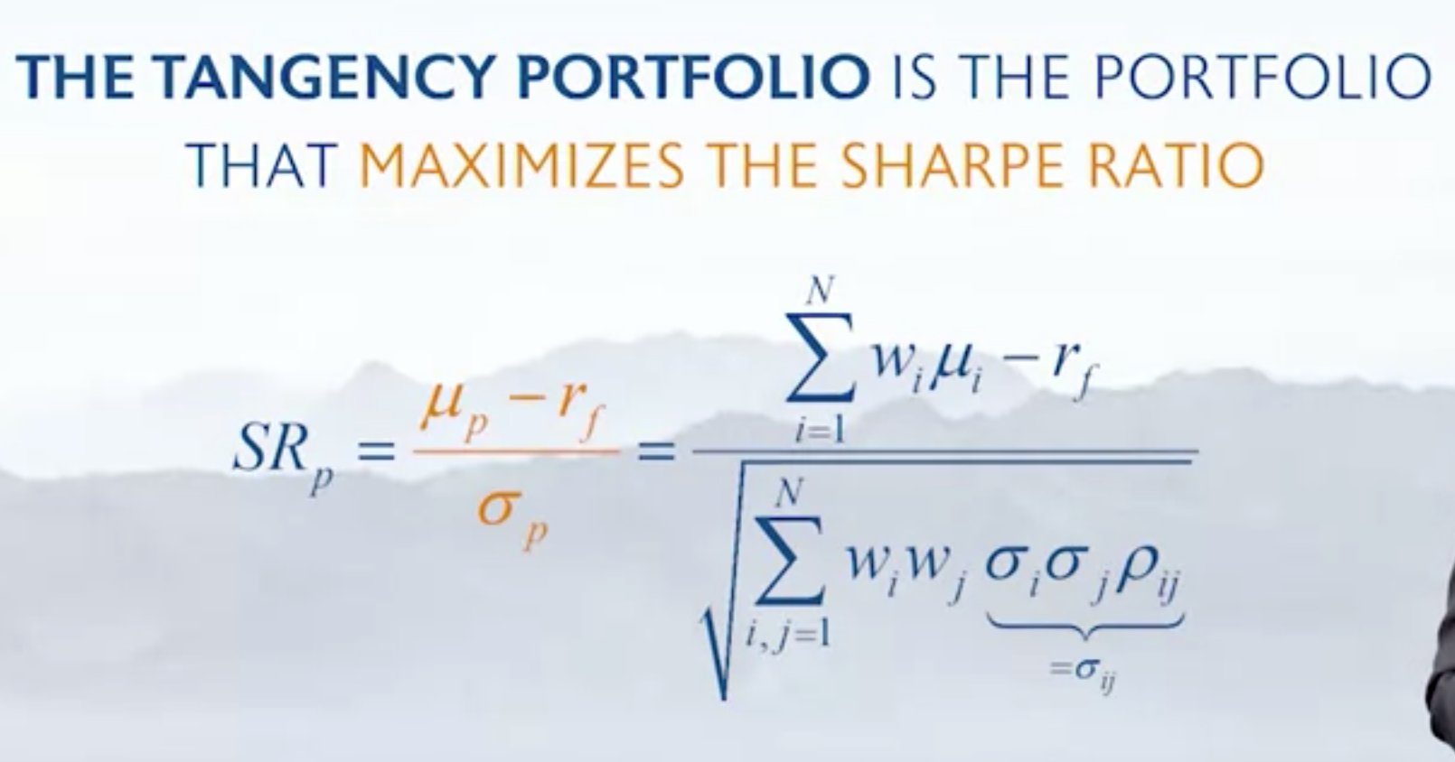

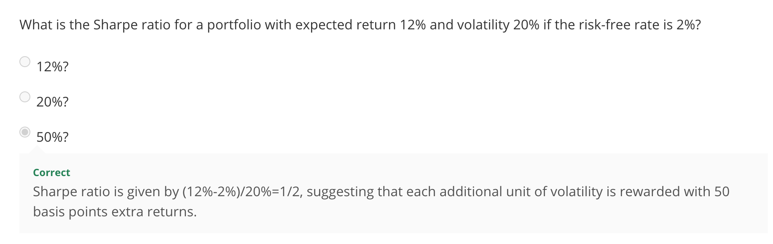

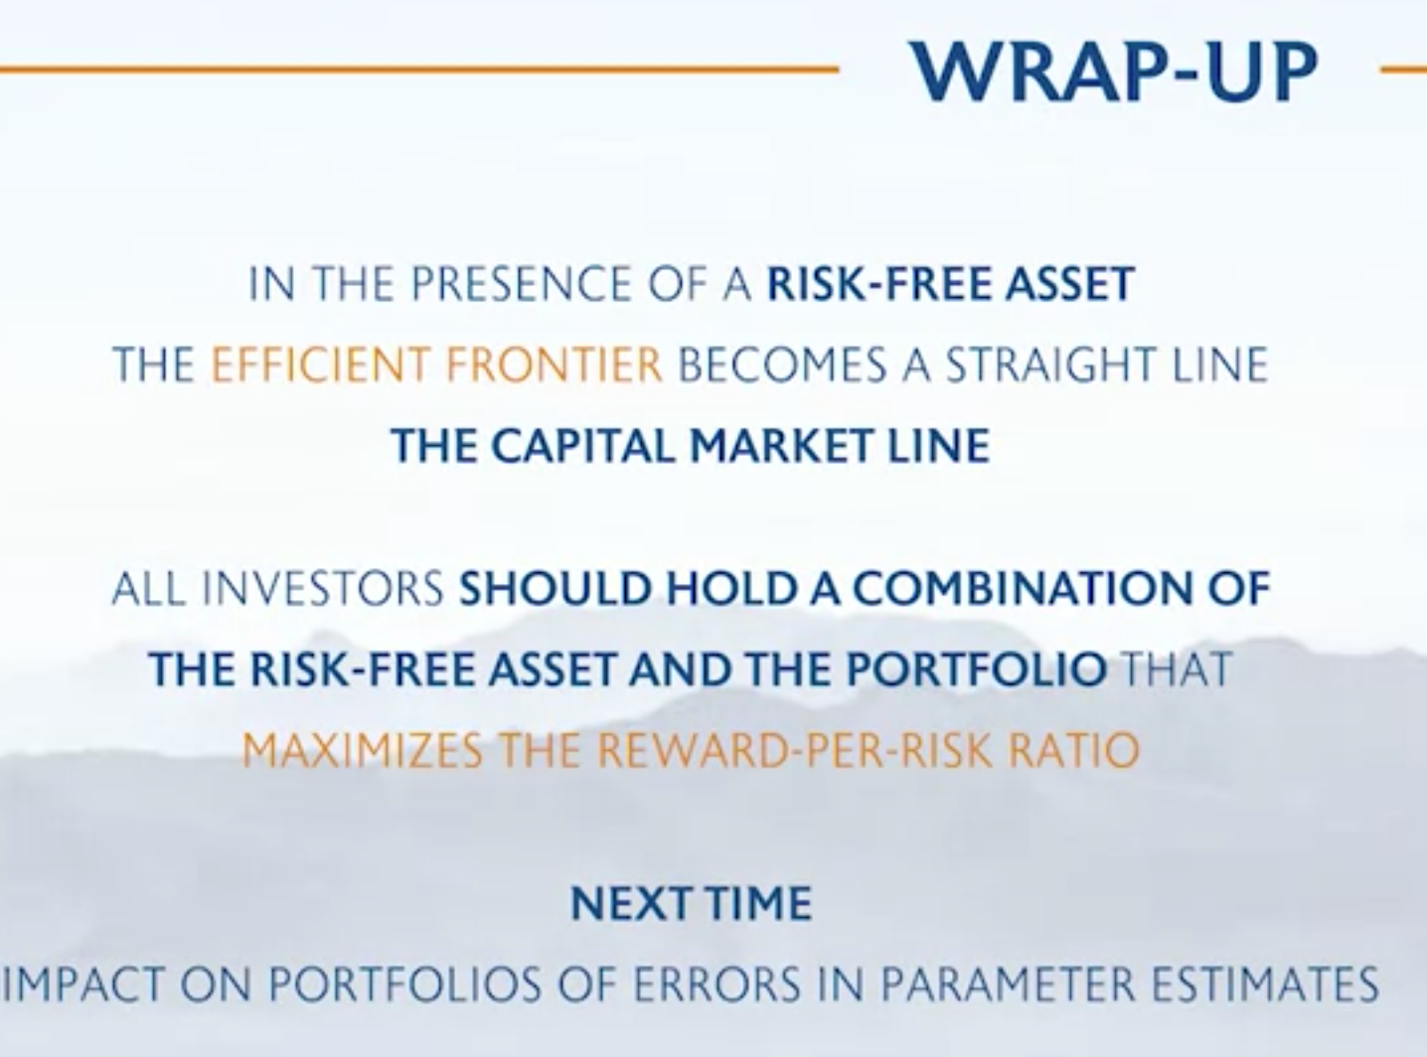

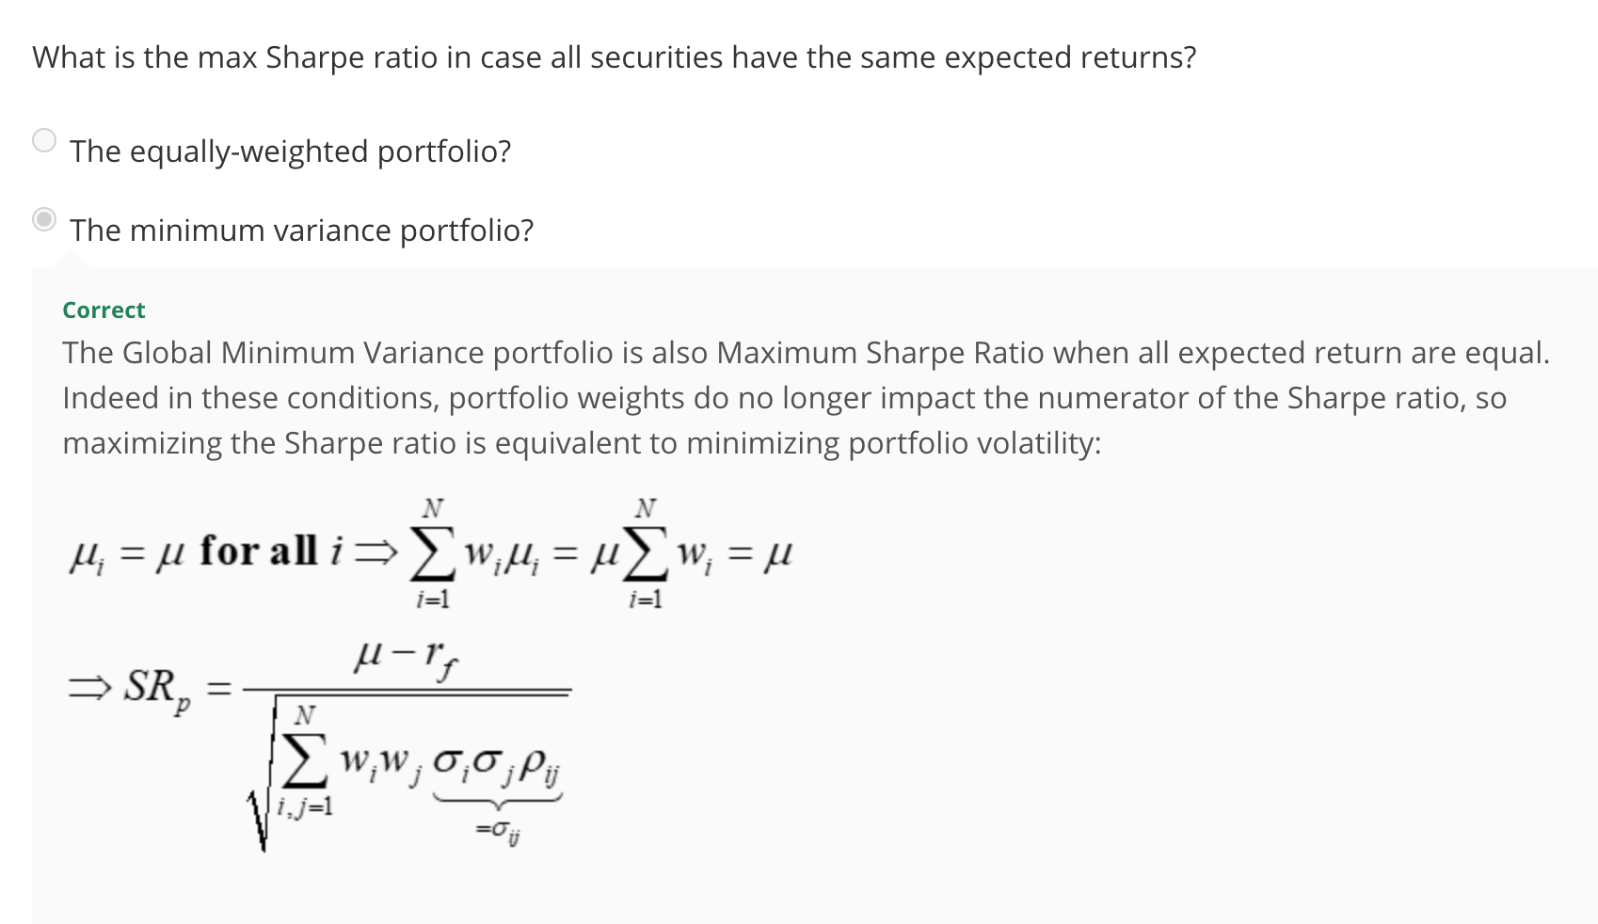

**Lack of robustness of Markowitz analysis**

* Optimizers can often amplify parameter estimation errors

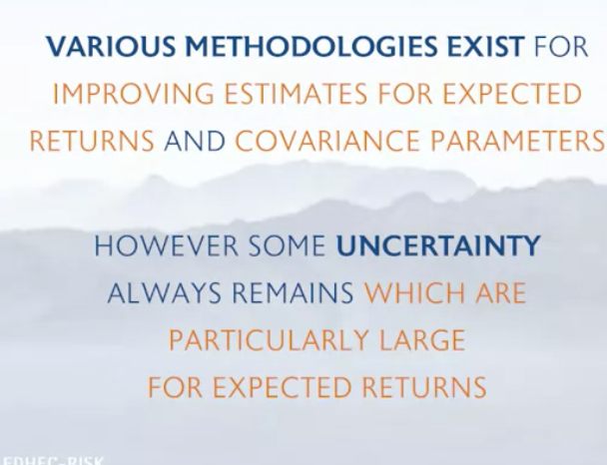

* Because expected return parameters are often noisy and unreliable, focus on the global minimum variance portfolio – it doesn’t rely on any return parameters

